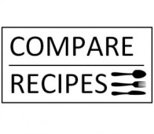

Nibbles/Snacks
Autumn/Winter

Salted Caramel Popcorn
Proper Crisps
Mixed Marinated Olives
Smoky Nuts
Root Vegetable Crisps

